Assignment no -7

Assignment based Password cracking

1.Jhon the Ripper

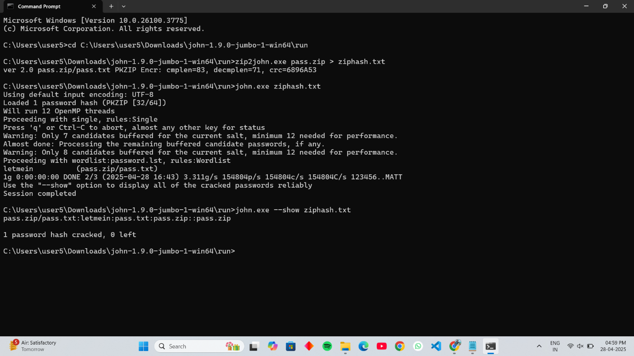

2. KRylack zip password recovery

